
paper Preparation guidelines
FOR MONGEOMETRIJA 2016
(Max. ARTICLE TITLE LENGTH: 5 lines; All letters capitalized; Times New Roman, 14pt, Bold; Spacing: Before: 20pt, After:10pt; No empty line below)
Akiro Takimoto
(The authors’ order of appearance must be the same as that of the corresponding
Abstract/Paper; Style of the paragraph: ‘<Author name’; Times New Roman, 10pt, Bold, Spacing: Before: 6pt, After: 0pt; No empty line below)
Affiliations, Knowledge Town, Republic of Success
PhD., Associate Professor, akiro@new.ac.ss
(Style of the paragraph: ‘<Correspondence details’; Each Appropriate Word With the First Letter Capitalized; Times New Roman, 10pt, Italic, Spacing: Before 6pt, After: 0pt; No Empty Line Below)
Peter Johanssen
(Style of the paragraph: ‘<Author name’; Times New Roman, 10pt, Bold, Spacing: Before 6pt, After: 0pt, no empty line below)
Affiliations, Knowledge Town, Republic of Success
PhD., Associate Professor, akiro@new.ac.ss
(Style of the paragraph: ‘<Correspondence details’; Each Appropriate Word With the First Letter Capitalized; Times New Roman, 10pt, Italic, Spacing: Before 6pt, After: 0pt; No Empty Line Below)
ABSTRACT (Style: ‘<abstract Title’; 10pt, Bold, italic, spacing: before: 12pt, after 0pt)
These Preparation Guidelines aim to give to potential participants the necessary information relevant for the Papers submission to the 5th ICGG Conference ‘Mongeometrija 2016’. These Guidelines ought to be respected so that each Paper submitted has a consistent appearance. This document itself is formatted according to the required Formatting-styles (names consist of symbol ‘<’ ). Since it is supplied as a Microsoft WinWord file, it can be used as a proper template. We, therefor, strongly suggest Authors to replace the content of this file with their own (preserving the existent page-setup/formatting and no adding any extra line-spaces i.e. blank rows, except in the case of usage ‘Page-breaking Rules’). To facilitate and simplify the formatting of paper, it is also possible to paste the complete content from another source/ document, and then format it by simple selecting the titles, text, captions, etc., and then clicking the appropriate Style from the Styles gallery, at the Home tab (top ribbon). (Style of the paragraph: ‘<Abstract’; 10pt, Italic)
Keywords: computer graphics; descriptive geometry; photogrammetry; computer science; applied geometry (Style of the paragraph: ‘<Keywords’; 10pt, Regular)

General Information (Style: ‘<heading1’; All letters capitalized; 10pt, Bold, Spacing: Before: 12pt, After: 6pt; No empty line below)
Two versions of the Conference Proceedings will be provided: (‘<First paragraph’)
- an electronic version (‘The Electronic Proceedings’), and
- a printed version (‘The Book of Abstracts’). (‘<Bulleted list’)
The Electronic Proceedings will consist of all accepted Papers (in full) while the printed version will consist of Extended Abstracts only (as shortened versions of the corresponding Papers). (‘<First paragraph’)
The Paper (and its Extended Abstract) have to be written in English only. Both submitted documents will be reviewed prior to the final acceptance. The Paper will be published only if it is accepted together with its Extended Abstract. (‘<New paragraph’)
The Paper should be structured so as to gain: a description of the problem investigated, an application field that the problem belongs to, research stages performed, methods used, results obtained, conclusions formulated, description of other research planned/needed, and the listing of all references cited. (‘<New paragraph’)
The Paper and its Extended Abstract must have the identical Title as well as the authors’ order of appearance.
The formatting styles that should be applied on the Paper and on its corresponding Extended Abstract are the same for all their sections that are in common. (‘<New paragraph’)

2. paper length and its constituents (Style of the paragraph: ‘<heading1’; All letters capitalized; 10pt, Bold, Spacing: Before: 12pt, After: 6pt; No empty line below)
The body text of the Paper should start with an introduction, followed by the main body of text, and completed with conclusions, followed by a list of references. But, if appropriate, the Paper should be finalized with Acknowledgements and Notes on contributor(s) (if any). A Paper with no appendices is required. Footnotes should be placed at the bottom of the page of their first mention. (‘<First paragraph’)
The structure of the main body of the Paper is up to the Author(s), and it should be logically defined respecting the already pointed-out section-hierarchy in general and sized so that the total number of pages does not exceed 16 (including all footnotes, figures, tables, references, acknowledgement(s) (if any) and notes on contributor(s)). The first (Title-page) will be right-sided (i.e. even). (‘<New paragraph’)

2.1. Figures (‘<Heading2': Each Appropriate Word Capitalized; 10pt, Bold, Spacing: Before 6pt, After 0pt; No Empty Line Below)
The Image-layout (including necessary Caption-content) must be identical to that in the example below and scaled properly. Each Figure should be centred, Spacing: 12pt Before and After. (‘<First paragraph’)
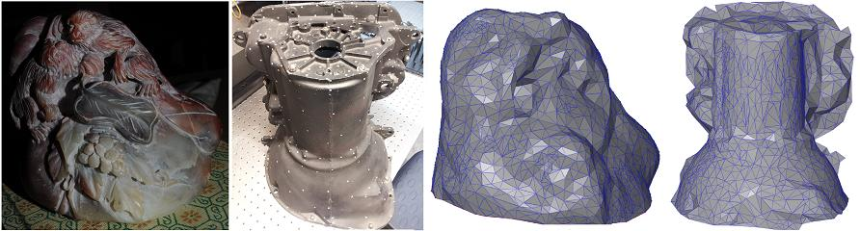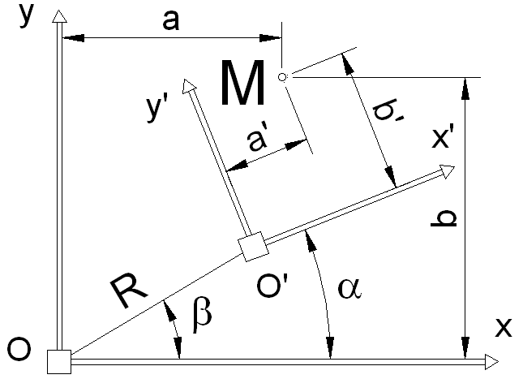
(a) (b)
Figure. 1: (a) Virtual model of the location, and (b) An image example of different nature
(Source: Johansen et al. (2012); illustrations modified with the Author’s written permission) (Style of the paragraph: ‘<Figure caption’; Times New Roman, 8pt, Spacing: Before: 0pt, After: 0pt, no empty line below)
Images/photos embedded have to be in one of the following formats: JPG,TIFF and PNG (minimum of 300 dpi should be used). (Style of the following paragraph (if any): ‘<New paragraph’ ; no empty line below)

2.2. Tables (‘<Heading2’: Each Appropriate Word Capitalized; 10pt, Bold, Spacing: Before 5pt, After 0pt; No Empty Line Below)
The table layout must be identical to that in the example below. Each Table should be centred. Tables must not be in the form of spread-sheets but WinWord created. (‘<First paragraph’)
Table 1: The parameters defined for different tests
(Source: Johansen et al. (2012); Table reproduced with the Author’s written permission)
(Formatting-Style: ‘<Table title’; 8 pt. Spacing: Before 12pt, After 6pt; no empty line below)
Site | Adjusted  R2 | Mean error (m) | Standard deviation  of error (m) | % of points  ‘‘good’’ | % of points  ‘‘fair’’ | % of points  ‘‘poor’’ | Codes of points interpolated
Full site | 99.96 | 0.320 | 0.154 | 16.7 | 40.9 | 31.6 | 10 B 8
Sub-scene | 98.32 | 0.310 | 0.165 | 25.7 | 27.9 | 35.2 | 11 B 2
(Table-filling Style: ‘<Table filling’; Style of the following paragraph (if any): ‘<First paragraph’; No empty lines before and after the table) (‘<First paragraph’)

2.3. Mathematics (Heading2: Each Appropriate Word Capitalized; 10pt, Bold, Spacing: Before 6pt, After 0pt; No Empty Line Below)
To respect proper mathematical conventions as well as to minimise the Author’s effort including that on the part of the copyeditors, the usage of Math-Editor is suggested. Each equation should be left-positioned while its naming should be right-positioned (as follows):
( Eq.1)
$v=L^{−1}{\left({\text{BLB}}^{T}\right)}^{−1}\text{Ax}+w$ ( Eq.2)
(Style of the following paragraph (if any): ‘<New paragraph’)

2.4. Displayed Quotations (Heading2: Each Appropriate Word Capitalized; 10pt, Bold, Spacing: Before 6pt, After 0pt; No Empty Line Below)
‘Displayed quotations ought to be indicated by ‘single’ quotation marks (‘) and positioned in the text where it is necessary. Only ‘longer’ quotations (with more then 40 words) must be located separately, indented and formatted in this way’.

2.6. Page-breaking Rules (Heading2: Each Appropriate Word Capitalized; 10pt, Bold, Spacing: Before 6pt, After 0pt; No Empty Line Below)
There must not be empty/blank rows between consecutive single- and multi-line sections, except in the case of respecting following ‘Page-breaking rules’ that Author(s) has to apply in the final text-processing pass. (‘<New paragraph’)
Those ‘Page-breaking rules’ are:
- No headings may be located at the bottom of a page - without a minimum of 2 ending rows of subsequent text: if else, the headings must be pushed up to the very top of the next page,
- In case of enumeration, at least one numbered (or bulleted) item should be placed immediately after the introductory sentence at the same page. If it is not possible, the introductory sentence should be moved to the beginning of the following page,
- The total number of pages should not excede 10.
- The last page must be completed at a rate off at least 50%. (‘<Bulleted list’)

Acknowledgements (Style of the paragraph: ‘<heading1’)
Only sources of project funding (if any) should be acknowledged. Such acknowledgements should be located at the end of the body text of the Paper.

References (Style of the paragraph: ‘<heading1’; All letters capitali-zed; 10pt, Bold, Spacing: Before: 12pt, After: 6pt; No empty line below)
Unpublished results and inter-personal communication are not recommended in the reference list, but may be mentioned in the text (if these references are included in the reference list they should follow the reference style shown below – including a substitution of the publication date with one of the following notes: either with ‘Unpublished results’ or with ‘Personal communication’. Citation of a reference as ‘in press’, implies the fact that ‘it has already been accepted for publication’). (‘<First paragraph’)
The reference list should be alphabetically ordered (by the surname of the first Author) and formatted (by using its own style: ‘References’). That list must have at least 2 relevant items. (‘<First paragraph’)
According to a concrete type of reference item, there are several possibilities:

Referencing to articles that have appeared in periodicals: (‘<Heading4’: Only appropriate words capitalized)
1. Chandler, J. H. and Padfield, C. J., 1996. Automated digital photogrammetry on a shoestring. Photogrammetric Record, 15(88). pp 545–560. (Current Style: ‘<References’)

Referencing to books: (‘<Heading4’: Only appropriate words capitalized)
2. Wolf, P. R., 1983. Elements of Photogrammetry. Second edition. McGraw-Hill, New York, USA. (Current Style: ‘<References’)

Referencing to edited books: (‘<Heading4’: Only appropriate words capitalized)
3. Wise, S. M., 1998. The effects of GIS interpolation errors on the use of digital elevation models in geomorphology. Chapter 7 in Landform Monitoring, Modelling and Analysis (Eds. S. N. Lane, K. S. Richards and J. H. Chandler). Wiley, Chichester. pp 139–164. (‘<References’)

Referencing to Papers that have appeared in a long-running series of various Archives, even if they appeared on CD-ROM firstly or as to a loose Papers at the Workshops, Symposiums or Congresses (‘<Heading4’: Only appropriate words capitalized)
4. Tovari, D. and Pfeifer, N., 2005. Segmentation based robust interpolation – a new approach to laser data filtering. International Archives of Photogrammetry, Remote Sensing and Spatial Information Sciences, 36(3/W19). pp 79–84. (‘<References’)

Referencing to edited Conference Proceedings: (‘<Heading4’: Only appropriate words capitalized)
5. Fourstner, W. and Guilch, E., 1987. A fast operator for detection and precise location of distinct points, corners and centres of circular features. Proceedings of ISPRS Intercommission Conference on Fast Processing of Photogrammetric Data, Interlaken, Switzerland. pp. 281–305. (‘<References’)

Referencing to Web-sites: (‘<Heading4’: Only appropriate words capitalized)
6. DETR, 1998. http://www.construction.detr.gov.uk/cis/rethink/6.htm [Accessed: 1st December 1999]. (‘<References’)

- NOTE: All the text that is presented in color is just for instruction, and should be deleted.

Generally, a text of both the Paper and the Extended Abstract has to be prepared IDENTICALLY - by Microsoft WinWord processor, using A4 (210 mm x 297 mm) single-column pages. The effective working area of each page is defined by the margins: Top - 2.5 cm, Bottom - 2.0 cm, Left – 2.0 cm, Right – 2.0 cm (Gutter - 1 cm, Left). Header and footer positions from relevant edges of the A4 paper are: 2.0 cm i.e. 1.0 cm. The default Tab-stop should be set to 0.75 cm. All text should be typed in Times New Roman font and mainly be fully justified (that is on both left and right sides). The main text uses10 pt. (including the Abstract and the Reference list), Article Title uses 14 pt. font, while footnotes, figure/table captions (labels) and longer quotations are in 8 pt. font. Single quotation-mark (‘) is allowed only. (Current Style: ‘<Footnotes’)

